1. General Build Tips
- X is left / right. Y is backwards / forwards. Z is up / down.
- De-grease the rods. Acetone or methylated spirit works.
- All screws have a plain washer where they meet the plastic, to spread the load and prevent the plastic being chewed up by the rotation of the screw head. Most fixings have a captive Nyloc nut to prevent them vibrating loose. It is very important that the nut is fully seated in the nut trap while the screw is inserted. They are quite a tight fit, so sometimes it is necessary to pull or push them in with a long screw.
- The X and Y bar clamps should not be over tightened, i.e. do not close the gap fully or the parts will break. The Y and Z bars only need a light clamping force because the only force trying to slide them is the bearing friction.
- Washers tend to have a smooth side and a side with a burr from being stamped out. Make sure the smooth side faces bearings and belts.
- Ribbon clamp notation is <number of wires>_<hole size>. There are three lengths: the short ones are 14 way for the X axis, the medium ones are 20 way for the Z axis and the long ones are 26 way for the bed. An N suffix denotes with nut traps. B denotes no slot.
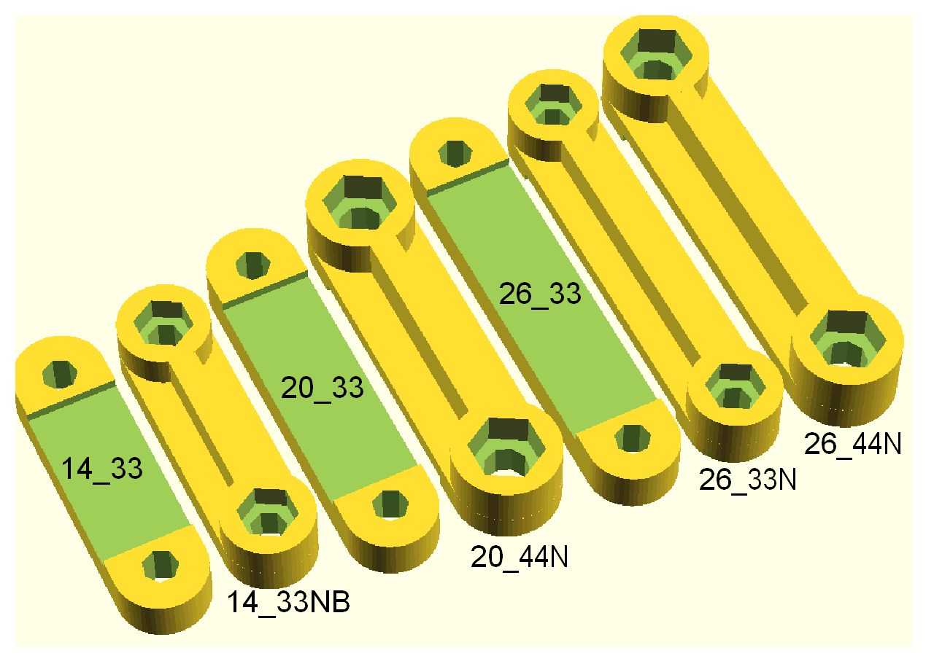

Tools Required
- Allen keys: 2.5mm & 3mm
- Needle nose pliers.
- 8mm sharp drill bit
- Drill with variable speed
- Small hammer
- Marker or pen
- M3 tap

- Wire cutters.
- Wire strippers.
- Soldering iron.
- Digital callipers.

Recommended
- Multi-meter
- Dial gauge (to level the bed more precise than paper method)
- Set of feeler blades
- Heat gun for heat shrink tubing… far better than lighter or soldering iron
- Ruler and square. Even thou it should be 90 degrees, it does not hurt to check.

Consumables
- oil, white lithium grease, alcohol (for cleaning bed), lint free wipes.

